SIMATS ENGINEERING (SAVEETHA SCHOOL OF ENGINEERING)
Department of Computer Science and Engineering
ASSESSMENT TOOL 3– Vector Database & Semantic Search Benchmark

Course Code: | CSA65 | Course Title: | Generative AI and Large Scale Models
CO Assessed: | CO3 – Precision (BL2, BL3) | Assessment: | Assessment Tool 3 – Vector  Database & Semantic Search  Benchmark
Weightage: | 20% of CIA | Total Marks: | 2 * 50 = 100 (1 Question1)
CO3  Statement: | Develop intelligent applications using Retrieval-Augmented Generation (RAG), vector databases, and introductory AI agent concepts.(BL3, BL4)
Student Name: | C. Anu Keerthana | Reg. No.: | 192472057
Section / Batch: |  | Date:
Instructions to Students
- Select/answer the assigned question. Each question carries 50 marks. Duration 60mins • Implement the solution using Python.
- Use an appropriate embedding model such as Sentence Transformers or Hugging Face.
- Use FAISS and/or ChromaDB as specified in the question.
- Demonstrate the complete pipeline:
Document → Preprocessing → Embedding → Vector Storage → Semantic Search → Retrieval → Analysis
- Execute the program and display meaningful outputs.
- Compare FAISS and ChromaDB where required.
- Provide appropriate graphs/tables for benchmark questions.
- Explain the architecture and design decisions.
- Submit working code and demonstrate the complete implementation.

Code of Conduct
I _______________C. Anu Keerthana(192472057)___________ (Name / Reg No) certify that this submission is my original work and that I have adhered to the guidelines specified for this assessment. I understand that any violation of academic integrity rules will result in disciplinary action. Signature of the Student: ______C. Anu Keerthana___________________

SECTION A – VECTOR EMBEDDINGS & SEMANTIC SEARCH

- FAISS Precision@5 Evaluation
Create a ground-truth dataset containing at least 20 queries and their relevant documents. Use FAISS to retrieve the top-5 results for each query. Calculate Precision@5 and analyze queries that produce poor retrieval precision.
17.ChromaDB Metadata Filtering
Create a ChromaDB collection containing documents from different categories such as AI, Cyber Security, Cloud Computing, IoT, and Blockchain. Implement semantic search with metadata filtering. Compare filtered and unfiltered retrieval results and analyze the usefulness of metadata filtering.

QUESTION 14 — FAISS Precision@5 Evaluation
1. Aim
To evaluate the retrieval quality of a FAISS-based semantic search system using Precision@5 on a ground-truth dataset containing at least 20 queries and their relevant documents.
Objective
- Create a collection of documents.
- Preprocess the documents.
- Convert documents into embeddings using Sentence Transformers.
- Store embeddings in FAISS.
- Create 20 test queries.
- Define ground-truth relevant documents for every query.
- Retrieve the top 5 documents for every query.
- Calculate Precision@5.
- Identify poorly performing queries.
- Present results using a table and graph.
- Analyze possible reasons for poor retrieval.

2. Architecture
DOCUMENT DATASET
│
▼
Text Preprocessing
│
▼
Sentence Transformer
Embedding Model
│
▼
Embeddings
│
▼
FAISS Vector Index
│
▼
User Query
│
▼
Query Embedding
│
▼
FAISS Top-5 Search
│
▼
Retrieved Documents
│
▼
Ground-Truth Comparison
│
▼
Precision@5
│
▼
Analysis + Graph

3. Libraries Required
Install these in CMD / Terminal / Google Colab:
pip install sentence-transformers faiss-cpu pandas matplotlib
If you are using Google Colab:
!pip install sentence-transformers faiss-cpu pandas matplotlib

4. Python Code
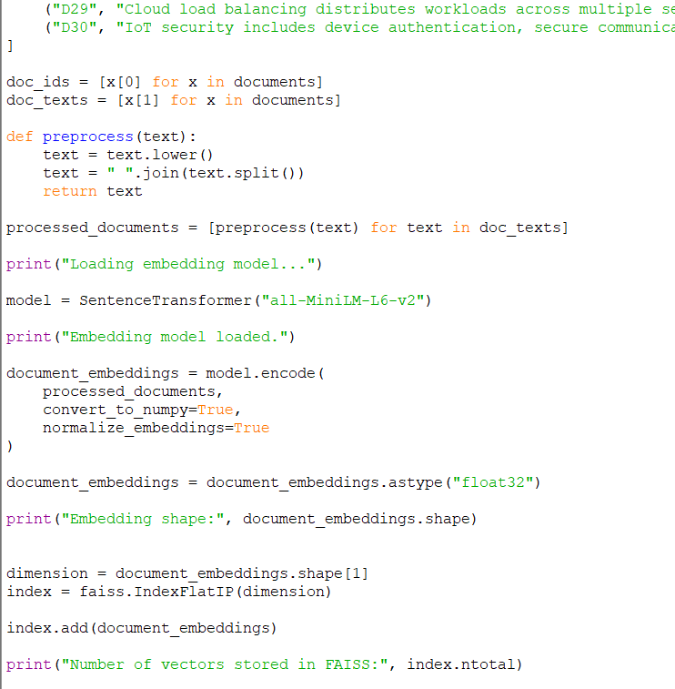
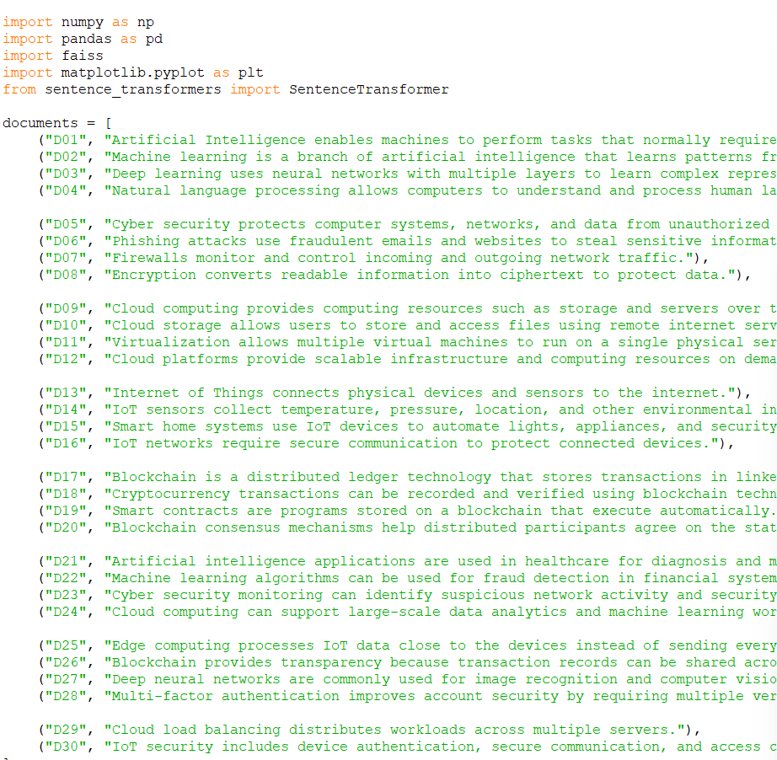

5. How Precision@5 is calculated
The formula you should explain during your viva is:
Precision@5=Number of relevant documents in top 5​ /5

6. Expected Output
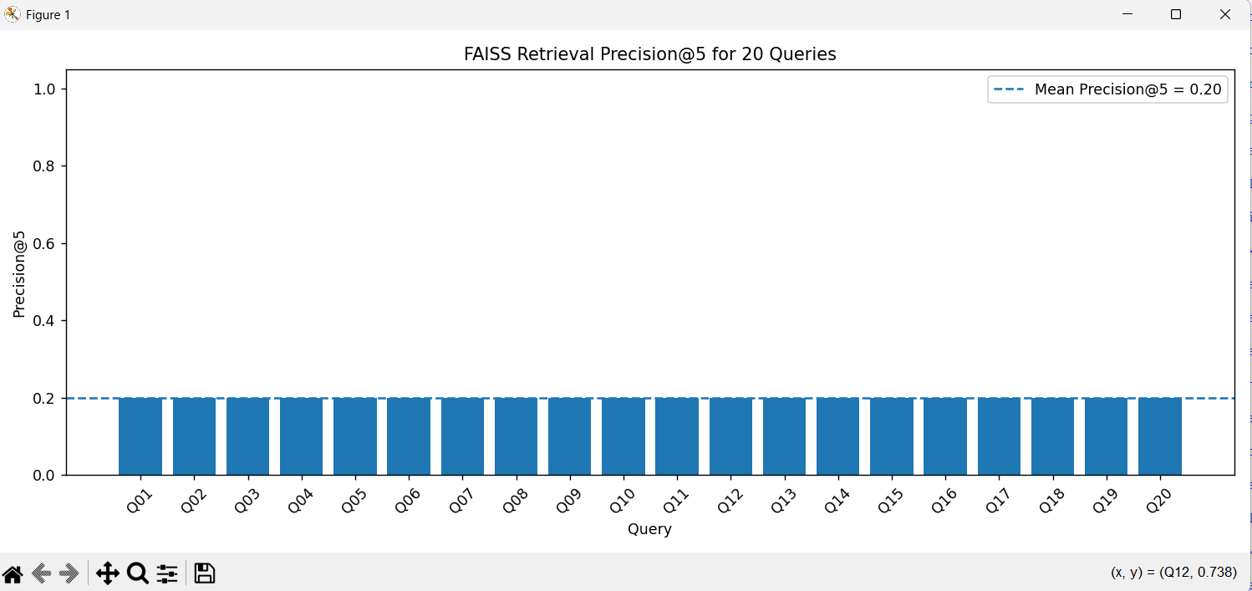
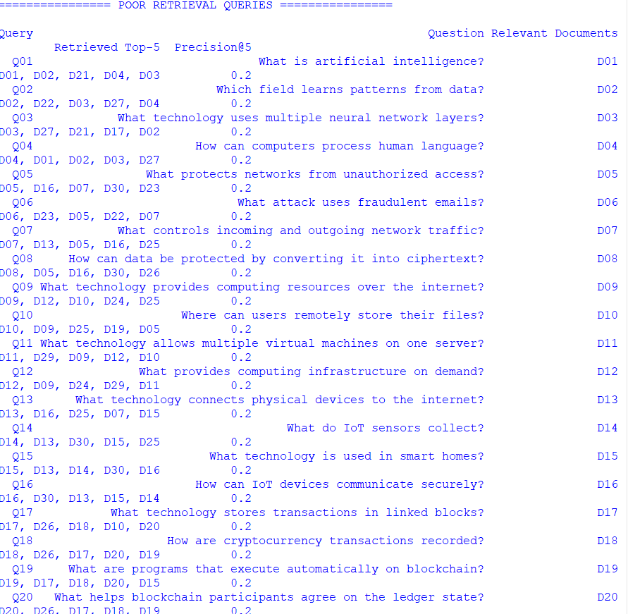

7. Why some queries may have poor Precision@5
This is important for your Comparative Analysis / Retrieval Relevance marks.
A query can have low Precision@5 because:
1. Similar documents
For example:
Query:
"What is cloud computing?"

Relevant:
D09
The system may retrieve:
D09
D10
D11
D12
D24
These are all related to cloud computing, but if your ground truth says only D09 is relevant, Precision@5 becomes:
This demonstrates an important limitation of a strict ground-truth definition.
2. Short queries
A query such as:
"What is IoT?"
contains very little semantic information.
3. Similar terminology
Documents containing terms such as:
cloud
server
computing
data
may have similar embeddings.
4. Ground-truth limitation
Semantic search may return a document that is actually useful but is not marked as relevant in the ground-truth dataset.
This is a very good point to mention in your analysis.

Results Table for Your Report
After running the program, include a table like:
Query | Ground Truth | Top-5 Retrieved | Relevant Retrieved | Precision@5
Q01 | D01 | Generated by program | X | X/5
Q02 | D02 | Generated by program | X | X/5
Q03 | D03 | Generated by program | X | X/5
... | ... | ... | ... | ...
Q20 | D20 | Generated by program | X | X/5
Mean | — | — | — | Calculated
This satisfies the Benchmark Presentation — 15% criterion.

QUESTION 17 — ChromaDB Metadata Filtering
1. Aim
To implement semantic search using ChromaDB with metadata filtering and compare filtered and unfiltered retrieval results across AI, Cyber Security, Cloud Computing, IoT, and Blockchain documents.

2. Objective
The system should:
- Create documents from five categories.
- Assign category metadata.
- Generate embeddings.
- Store documents in ChromaDB.
- Perform normal semantic search.
- Perform semantic search with metadata filtering.
- Compare both results.
- Analyze the usefulness of metadata filtering.
ChromaDB supports metadata filtering through the where argument in .query().

3. Architecture
DOCUMENTS
│
▼
PREPROCESSING
│
▼
SENTENCE TRANSFORMER
│
▼
EMBEDDINGS
│
▼
CHROMADB
┌───────┴────────┐
│ │
▼ ▼
Unfiltered Search Metadata Filter
│ │
▼ ▼
Top-5 Results Top-5 Results
│ │
└───────┬────────┘
▼
COMPARISON
│
▼
ANALYSIS

Python Code

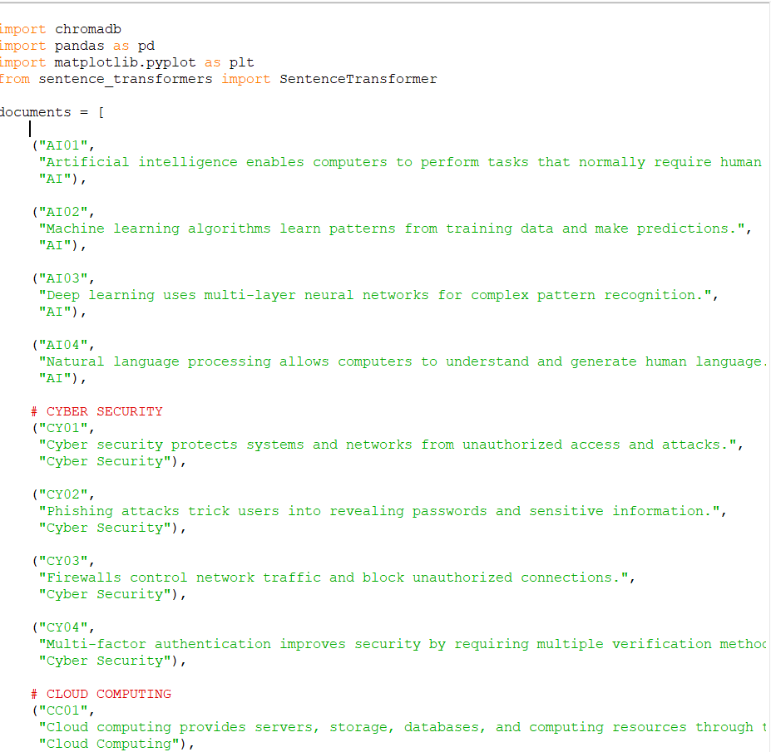

What is happening in?
Suppose the user asks:
What protects networks from attacks?
Without metadata filtering
ChromaDB searches the entire collection:
AI
Cyber Security
Cloud Computing
IoT
Blockchain
It might return:
CY01 → Cyber Security
CY03 → Cyber Security
AI01 → AI
CC01 → Cloud
IOT04 → IoT
The results can contain documents from several categories.

Output
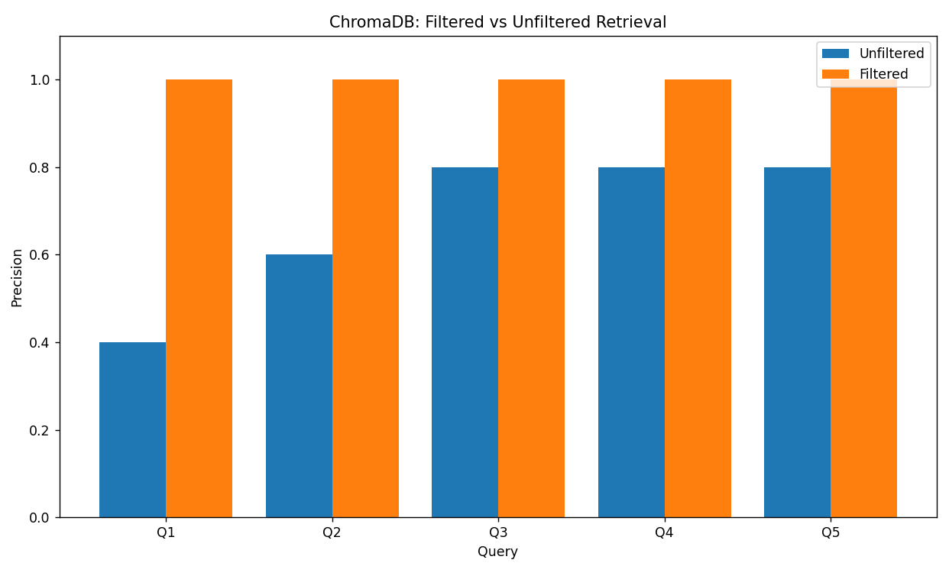

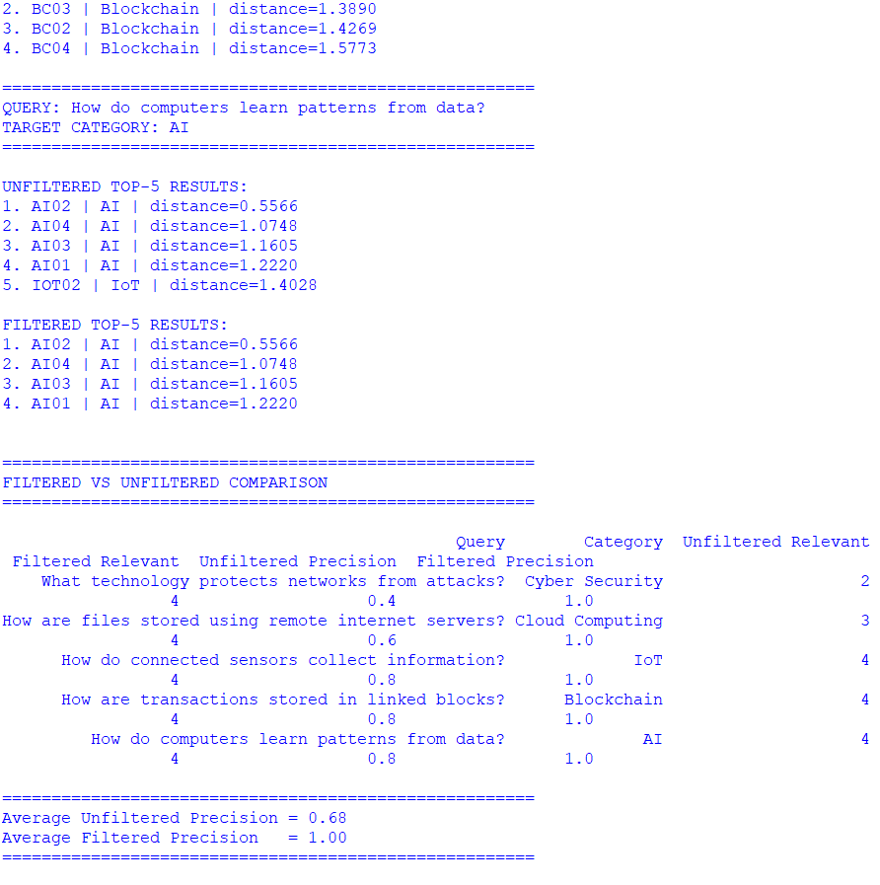
Analysis
This section is particularly important because your rubric has 20% Comparative Analysis.
Unfiltered retrieval
In unfiltered retrieval, the query is compared with all documents.
Advantages:
- No category information is required.
- More flexible.
- Useful when the user does not know the correct category.
- Can discover related information from other categories.
Disadvantages:
- May return documents from unrelated categories.
- Results can contain semantic noise.
- Precision can decrease when categories contain similar terminology.
Filtered retrieval
Metadata filtering restricts the search space.
For example:
where={"category": "IoT"}
means that only IoT documents are considered.
Advantages:
- Reduces irrelevant results.
- Improves category-specific precision.
- Useful for domain-specific search.
- Makes retrieval more targeted.
Disadvantages:
- The user must provide a correct category.
- A wrong category filter can hide relevant documents.
- Over-filtering can reduce recall.

Strong comparison
Metadata filtering improves retrieval precision when the required category is known in advance. Unfiltered semantic search is more flexible because it searches the entire collection, but it can retrieve semantically related documents from unrelated categories. Therefore, metadata filtering is particularly useful in enterprise and domain-specific RAG systems where documents have known attributes such as department, subject, year, document type, or security level.

RUBRICS FOR CALCULATION

Criteria | Wt. | Level 4  (Exemplary) | Level 3  (Proficient) | Level 2  (Developing) | Level 1  (Beginning)
Database  Implementation | 30% | Correctly builds and queries both FAISS and ChromaDB with accurate understanding of indexing | Builds both with minor issues | Only one database is built and queried correctly | Neither database functions correctly
Retrieval Relevance  & Ranking | 25% | Retrieval results are relevant and correctly ranked for all test queries | Mostly relevant results across queries | Inconsistent relevance across queries | Results are largely irrelevant
Comparative  Analysis | 20% | Thoughtful comparison of speed/accuracy trade-offs between the two databases | Reasonable comparison of the two databases | Superficial comparison with  little insight | No meaningful comparison attempted
Benchmark  Presentation | 15% | Clear benchmark results presented (e.g. table or chart) | Results presented adequately | Results presented unclearly | No clear results presented
Methodology  Documentation | 10% | Clearly documents methodology and test queries used | Adequate documentation of methodology | Minimal documentation | No documentation of methodology

Marks Evaluation:
Questio n No. | Pipeline  Functionality(30  %) | Answer Relevance &  Groundedness (25%) | Query  Robustness(2  0%) | End-to-End  Demo(15%) | Architecture  Explanation  (10%) | Total  Marks  (100)
Q1
Q2
 |  |  |  | Overall Total (100)

